Differences in Workers Stress Scores for Physical, Mental, Behavioural and Emotional Conditions

Contents:
Page
Abstract 3
Review of Literature 4
Methodology 6
Results 8
Analysis and Discussion 17
Summary and Conclusion 21
Bibliography 22
References 23
Appendices 24

Acknowledgements:
2 members of the research group were working together.
Thank you to all participants.
Abstract
The theoretical background of the study was occupational psychology and biopsychology.
This investigation was a field experiment with repeated measures design. A Self-rating Scale (Appendix 4) was used to measure differences in scores of stress for physical, mental, behavioural and emotional conditions over a six month period of time.
Alternative Hypothesis: Participants will have different scores of stress under physical, mental, behavioural and emotional conditions. Null Hypothesis: There will be no difference between the stress scores under four different conditions.
The result is non significant at 20% level for two-tailed test (p>0.20).The dispersion of scores of stress under the first and fourth condition is higher than under the second and third condition. Females showed higher scores of stress than males under all conditions.
Limitations of the study: participants were somewhat stressed, the environment was a bit noisy and the sample size was small.
Self-reported data also has disadvantages.

Review of Literature
Holmes and Rahe (1967, cited in Gross, 2010, pp. 186-187) developed the Social Readjustment Rating Scale (SRRS) to assess life events of varying seriousness. Some work related life events from this scale are: change to different line of work, change in responsibilities at work, trouble with the boss and change in working hours or conditions. Rahe, Mahan and Arthur (1970, cited in Eysenck, 2009, p. 91) used the SRRS scale to divide naval personnel into low-risk and high-risk groups on the basis of their life events over the previous six months. Members of the high risk group were twice as likely to develop illnesses during their first month at sea.
Frankenhaeuser (1975, cited in Eysenck, 2009, p. 90) found a link between perceived lack of control and high level of stress. Sawmill workers who had less control and were isolated suffered far more from headaches, digestive disorders such as ulcers and high blood pressure than other mill workers.
A similar research by Bosma, Stanfeld and Marmot (1998, cited in Eysenck, 2009, pp. 90-91) found that civil servants on the lowest employment grades were four times more likely to suffer from strokes, cancer and gastrointestinal disorders than those on the most senior grade. These correlation based results do not prove the lack of control caused the diseases. There are a number of other work factors affecting workers’ psychological well-being.
Rivera-Torres P., Araque-Padilla R. and Montero-Simó M.J. (2013, pp.375–389) studied gender differences regarding the effect of perceived job demands, control and support on how individuals reach high levels of job stress. The results showed that only one dimension of the job demands stressor was significant (quantitative demands) for men and the job stress is weakened slightly by the effects of control and support. In contrast, emotional and intellectual aspects (qualitative demands) are also statistically significant for women. Moreover, social support has a greater weakening effect on the levels of job stress in women than in men.
According to Colman (2001, cited in Eysenck, 2009, p. 87) stress is the psychological and physical tension generated by physical, emotional, social, economic or occupational circumstances, events or experiences that are difficult to manage or sustain. There are the four main kinds of effects of being exposed to stress: physiological, emotional, cognitive and behavioural.

Methodology
A Self-rating Scale (Appendix 4) was used to measure differences in scores of stress for physical, mental, behavioural and emotional conditions over a six month period of time. This method was chosen because it allowed to the collection of the same information from all participants in a short period of time and person characteristics would be the same under all conditions.

Researchers approached participants. Researchers read the Introduction (Appendix 1) and they gave one Consent page (Appendix 2) to each participant. Participants all agreed to participate in this research, they confirmed they were over 18 and they filled in the Consent page (Appendix 2). A brief explanation of the research followed and standardised instructions were given (Brief and Instructions – Appendix 3). Self-rating Scale pages (Appendix 4) were provided for participants. Participants filled in the Self-rating Scale (Appendix 4). The Debrief (Appendix 5) was read to participants. Data Respond Sheets(Appendix 6) were collected after they had agreed that the information provided was going to be used in this research – they ticked the box atthe bottom of the Consent page (Appendix 2). Later the Mark Sheet (Appendix 7) was used to calculate scores on the Score Sheet (Appendix 8). Participants’ scores and data were written on the Raw Data Sheet (Appendix 9). Afterwards Descriptive Statistics (Appendix 10) and Friedman inferential test were calculated (Appendix 11).

In this research opportunity sampling was used. 30 adult employees were tested. Participants were researchers’ colleagues, friends and family members from Norwich. It included 15 females and 15 males. Eight participants had age range 18-25, eight participants had age range 26-33, six participants had age range 34-41, three participants had age range 42-49 and five participants had age range 50 and over. For more details about participants see Raw Data Sheet (Appendix 8).
IV is physical, mental, behavioural and emotional conditions. DV is participants’ scores of stress.
All participants were tested in a one-week period. They were all given the same Self-rating Scale (Appendix 4). They were tested in a home environment (14 participants) or in a work environment (16 participants).
This investigation had ordinal level of data and four conditions. Therefore, median and range (Appendix 10; Table1) and the Friedman inferential test (Appendix 11)were calculated.

Results
Table 1
Summary Table of Measures of Central Tendency and Dispersion
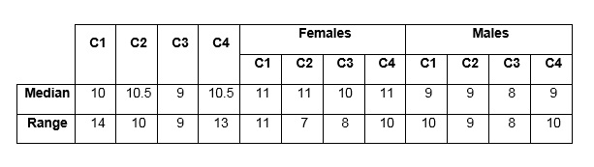
Key for Table 1, Table 2, Table 3 and Table 4:

C1 – Condition 1 – Scores of Physical Stress Level
C2 – Condition 2 – Scores of Mental Stress Level
C3 – Condition 3 – Scores of Behavioural Stress Level
C4 – Condition 4 – Scores of Emotional Stress Level
Scores – Values of Scores of Stress under Different Conditions

Table 1 shows the median and range of scores and the median and range for females and males under four conditions. Range values under the first and fourth condition are higher than under second and third condition. Yhe values of the median are slightly higher for males than for females. For calculations see Appendix 10.

Table 2
Frequency table
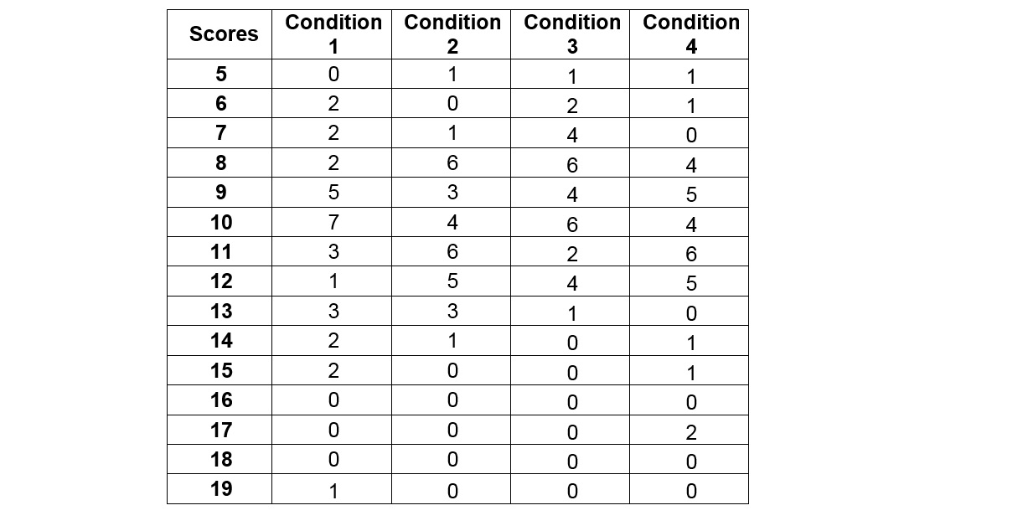
Table 2 shows the frequency of scores under four conditions.

Table 3
Frequency table of female participants’ scores
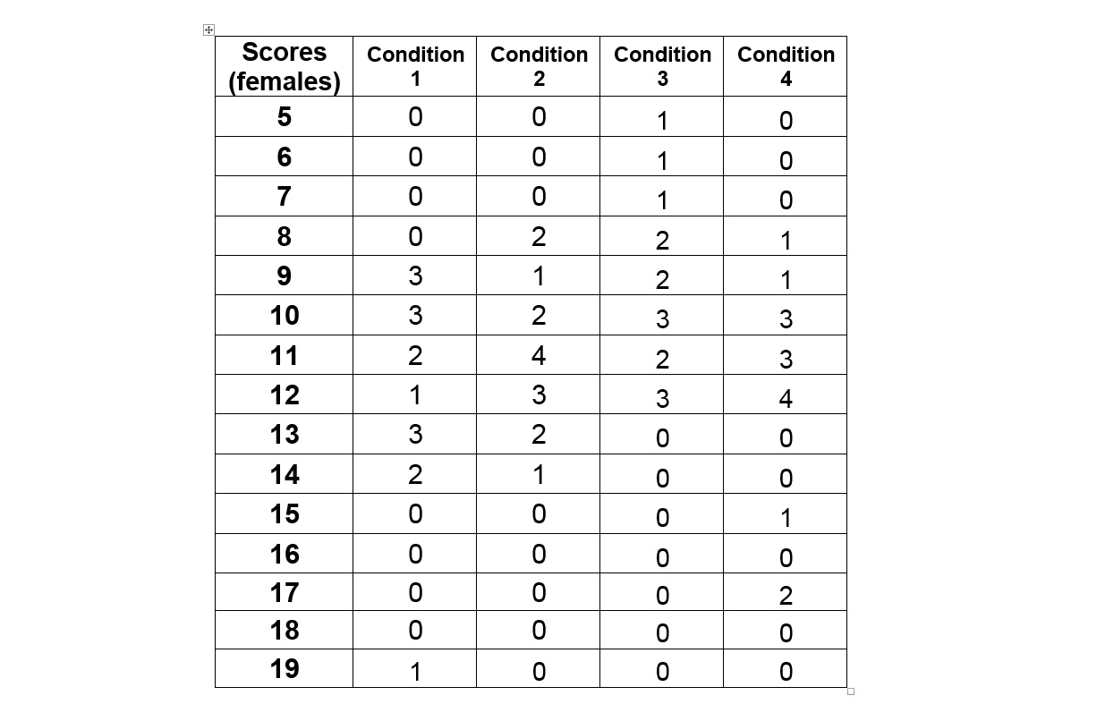
Table 3 shows the frequency of scores for female participants under four conditions.
Table 4
Frequency table of male participants’ scores
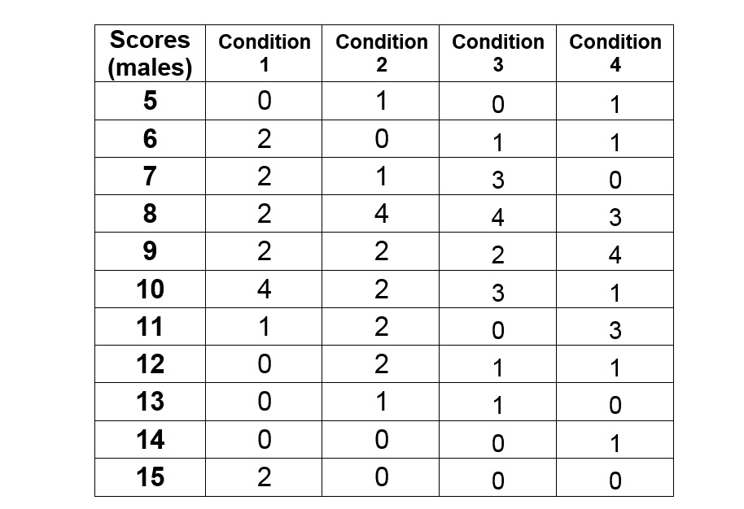
Table 3 shows the frequency of scores for male participants under four conditions.
Figure 1

Figure 1 shows the frequency of participants’ scores for physical condition. The score value 19 is slightly deviant.
Figure 2

Figure 2 shows the frequency of participants’ scores for mental condition.

Figure 3

Figure 3 shows the frequency of participants’ scores for behavioural condition.

Figure 4

Figure 4 is a shows the frequency of participants’ scores for emotional condition.

There arenot significant differences among the frequencies of scores under different conditions. However, the dispersion of scores in the Figure 1 and Figure 4 are bigger than in Figure 2 and Figure3.
Figure 5

Figure 5 shows the frequency of scores under physical condition for males and females.
Figure 6

Figure 6 shows the frequency of scores under mental condition for males and females. The score value 10 have the same frequency for males and females.
Figure 7

Figure 7 shows the frequency of scores under behavioral condition for males and females. The score value 6, 9 and 10 have the same frequency for males and females.
Figure 8

Figure 8 shows the frequency of scores under emotional condition for males and females. The score value 11 has the same frequency for males and females.
Higher scores of stress scores are more frequent for females than for males under all four conditions.
Figure 9

Figure 9 shows participants' age ranges within five age range categories. Age ranges are not equally represented. For calculations see Appendix 12.

Statistical conclusion:
The degree of freedom is df=3, the observed value is X²_{f} =0.86 and the critical value is X²_{f} =4.64the result is non significant at 20% level for two-tailed test (p>0.20)
Therefore, the Null Hypothesis cannot be rejected.
(see Appendix 11).
Most important findings:
The dispersion of scores of stress under the first and fourth condition are higher than under the second and third condition. Females have higher frequency of scores of stress under all conditions.

Analysis and Discussion
Similarly to the investigation with naval personnel, this investigation was assessing professionals over six months period. Work related events were not collected, so this research cannot be compared to the researches made by Rahe, Mahan and Arthur (1970, cited in Eysenck, 2009, p. 91).
Frankenhaeuser (1975, cited in Eysenck, 2009, p.90) found a link between perceived lack of control and high level of stress. Sawmill workers who had less control and were isolated suffered far more from headaches, digestive disorders such as ulcers and high blood pressure than other mill workers.
In this investigation participants’ perceived control and isolation at work are not known, so this research cannot be compared to the researches made by Frankenhaeuser (1975).
Bosma, Stanfeld and Marmot (1998, cited in Eysenck, 2009, pp. 90-91) found associations between the lack of control and various diseases. This does not prove, the lack of control caused diseases.
This study was not investigating associations between control and various diseases. Scores of stress might be related to perceived control at work or to various diseases, but this study cannot be compared with the research completed by Bosma, Stanfeld and Marmot(1998).
Rivera-Torres P., Araque-Padilla R. and Montero-Simó M.J found that only one dimension of the job demands stressor is significant for men and the job stress is weakened slightly by the effects of control and support. In contrast, emotional and intellectual aspects are also statistically significant for women. Social support has a greater weakening effect on the levels of job stress in women than in men (2013, pp.375–389).
This investigation is not entirely gender specific. The effects of demands, control and support were not measured. Nevertheless, higher scores of stress are more frequent for females than for males under all conditions, which might be related to the previous study.
According to Colman (2001, cited in Eysenck, 2009, p.87) stress is the psychological and physical tension generated by physical, emotional, social, economic or occupational circumstances, events or experiences that are difficult to manage or sustain. There are the four main kinds of effects of being exposed to stress: physiological, emotional, cognitive and behavioural.
This research is similar to Colman’s research, because scores of stress for physical, mental, behavioural and emotional conditions measured. However this investigation is focusing on the stress at work.

The result is not significant at 20% level for two-tailed test, so the Null Hypothesis cannot be rejected.
There were deficiencies is this investigation. The Brief and Instructions (Appendix 3) were not clear enough, however wording has helped to avoid distress. There were mistakes in the Self-rating scale (Appendix 4). Also, it was not clear for all participants when they needed to tick the box at the bottom of the Consent page (Appendix 2).
The sample size was small. In addition, the workplace was a bit noisy where some of the participants were tested and some participants did not listen carefully all the instructions.
As an improvements it is recommended to represent age ranges equally and to assess all participants at the same time and in the same environment. A bigger sample size is also recommended.
For amendments, it would be useful to compare stress level at different types of jobs. Also participants could be assessed as to whether or not they suffer from any disease to find an association between diseases and stress levels.
Ethical, gender and cultural issues:
One participant did not the tick box at the bottom of the Consent page. He was reminded to do that before Data Respond Sheets were collected.
Males and females were equally represented in this investigation.
During investigation females seemed a bit more stressed than males, which might have affected the results.
Some participants were foreign workers. Their poor understanding of English might have affected their understanding of instructions. This could be an ethical issue as well.
It would be interesting to find differences between the stress scores of English and Non-English workers.
Participants were from different organisations, so they have different stress factors.

Summary and Conclusions
Overall results did not show a significant difference between physical, mental, behavioural and emotional scores of stress. The dispersion of scores of stress under the first and fourth condition are higher than under second and third condition. Females showed higher scores of stress than males under all conditions.
The degree of freedom is df=3, the observed value is X²_{f} =0.86 and the critical value is X²_{f} =4.64the result is non significant at 20% level for two-tailed test (p>0.20).
The Null Hypothesis cannot be rejected.

Bibliography
Bosma, H., Stansfeld, S. A. and Marmot, M.G. (1998). Job control, personal characteristics, and hearth disease. Journal of Occupational Health and Psychology, 3, pp. 402-409.
Colman, A. M. (2001). Oxford dictionary of Psychology. Oxford, UK: Oxford University Press.
Eysenck, M. W. (2009) Fundamentals of Psychology. New York: Psychology Press,
Frankenhaeuser, M. (1975) Sympathetic-adreno medullary activity behaviour and the psychosocial environment. In P.H. Venables and M. J. Christie (Eds.), Research in psychophysiology. New York: Wiley.
Gross, R. (2010) The Science of Mind and Behavior. Abingdon: Hodder Education.
Holmes, T.H. and Rahe, R.H. (1967) The social readjustment rating scale. Journal of Psychosomatic Research, 11 (2), pp. 213–218.
NHS Foundation Trust (2013) Stress: ‘A self help guide’. Available at: http://www.ntw.nhs.uk/pic/leaflets/Stress%20A4%202013.pdf (Accessed: 12 November 2014)
Rahe, R. H., Mahan, J. and Arthur, R. 1970). Prediction of near future health change from subjects ‘preceding life changes. Journal of Psychosomatic Research, 14, 406-406.

Rivera-Torres P., Araque-Padilla R. and Montero-Simó M.J (2013) ‘Job Stress Across Gender: The Importance of Emotional and Intellectual Demands and Social Support in Women’ International Journal of Environmental Research and Public Health, 10(1): pp.375–389. doi: 10.3390/ijerph10010375

References
Eysenck, M. W. (2009) Fundamentals of Psychology. New York: Psychology Press,
Gross, R. (2010) The Science of Mind and Behavior. Abingdon: Hodder Education.
NHS Foundation Trust (2013) Stress: ‘A self help guide’. Available at: http://www.ntw.nhs.uk/pic/leaflets/Stress%20A4%202013.pdf (Accessed: 12 November 2014)

Rivera-Torres P., Araque-Padilla R. andMontero-Simó M.J (2013) ‘Job Stress Across Gender: The Importance of Emotional and Intellectual Demands and Social Support in Women’ International Journal of Environmental Research and Public Health, 10(1): pp.375–389. doi: 10.3390/ijerph10010375

Appendices
List of Appendices:
- Introduction (Appendix 1)
- Consent Page (Appendix 2)
- Brief and Instructions (Appendix 3)
- Self-rating Scale (Appendix 4)
- Data Respond Sheets (Appendix 6)
- Debrief (Appendix 5)
- Mark Sheet (Appendix 7)
- Score Sheet (Appendix 8)
- Raw Data Sheet (Appendix 9)
- Descriptive Statistics – Measures of Central Tendency and Dispersion (Appendix 10)
- Calculations for Friedman inferential test (Appendix 11)

Appendix 1
Introduction

Hello, my name is ……….. I am an undergraduate student at City College and was wondering if you might be willing to participate in my research.
Please tick the consent box on the top of the Consent page (Appendix 2) provided if you are over 18 and you are ready to participate in this research. Please tick the gender and age range section as well.
Please, do not tick the box below the line, yet. You will tick that after the Debrief.

Appendix 2 Participant number
Consent Page

Please tick the appropriate box:
Consent given: 
Gender:
Male  Female 
Age range:
18-25 26-33 34-41 42-49 50 and over
    

If you agree that your information provided to us is going to be used in this research please tick the following box: 

Appendix 3

Brief and Instructions
I am carrying out psychological research. I am going to give you a Self-rating scale. On each line please tick one answer that is most appropriate for you. All data and results will remain completely confidential and your identity will remain completely anonymous. Finally, you are entitled to withdraw from this research at any time.
Are you willing to continue?

Appendix 4 Participant number
Self-rating scale
Please tick how often have you experienced the following signs in the past six months at your workplace?
 |  | Never | Rarely | Sometimes | Often | Always
Headaches
Tension
Frequent colds
Sleep disturbances
Worrying
Mistakes
Inability to concentrate
Nervousness
Unsociability
Lying
Change in appetite
Increased smoke/alcohol
Moodiness
Anxious
Withdrawal
Irritability
(Data Respond Sheets are missing from this document - Appendix 5)

Appendix 6
Debrief
Thank you for participating in this research project.
In this research we are collecting data from participants self-rating of physical, mental, behavioural and emotional signs in order to measure their stress level at work.
Also we are obtaining information about gender and age range, in order to find out whether or not there are differences in the indication of stress level.
Examples from NHS Foundation trust leaflet ‘Top Tips to Tackle Stress’ were used to make our self-rating scale questions. We are using scores from the self-rating scale to calculate participants’ stress level. However this is not an adequate measure of stress. It is not unusual that people in some period of their life rate themselves higher than others. This investigation tried to avoid distress. However if you require any further help or advice, please contact your GP.
As stated in the Brief and Instructions, you will remain completely anonymous and the data you provided will remain completely confidential.
If you want to withdraw your results and data, please do it now because you will not be able to do this later. If you agree that your information provided to us may be used in this research please tick the box at the bottom of the Consent page.
Overall results can be requested by email between 01/11/2014 and 01/12/2014. However no individual results will be available. My college email address is…

Appendix 7
Mark Sheet

Answers from Data Respond Sheets (Appendix 6) were transferred on a five-point Likert type scale (never=one, rarely=two, sometimes=three, often=four, always=five). This Likert type scale was used to calculate participants’ scores for each condition (Appendix 8). Calculated scores and participants’ gender and age were copied to Raw Data Sheet (Appendix 9).
Condition one – Scores of Physical Stress Level(headaches, tension, frequent colds and sleep disturbances)

Condition two – Scores of Mental Stress Level(worrying, mistakes, inability to concentrate and nervousness)

Condition three – Scores of Behavioural Stress Level(unsociability, lying, change in appetite and increased smoke/alcohol)

Condition four – Scores of Emotional Stress Level(moodiness, anxiety, withdrawal and irritability)

Appendix 8
Score sheet
Participant number | Condition 1 | Condition 2 | Condition 3 | Condition 4
1 | 5+2+3+4=14 | 1+2+3+2=8 | 4+2+1+5=12 | 3+1+4+3=11
2 | 3+4+3+2=12 | 4+3+3+3=13 | 1+1+1+3=6 | 3+3+2+2=10
3 | 2+4+2+3=11 | 3+2+2+1=8 | 2+1+4+2=9 | 2+2+3+2=9
4 | 1+2+2+1=6 | 2+3+3+3=11 | 2+2+2+1=7 | 2+2+3+4=11
5 | 3+2+3+2=10 | 2+2+1+2=7 | 3+2+1+1=7 | 2+2+2+2=8
6 | 3+4+1+5=13 | 2+4+1+2=9 | 3+4+2+1=10 | 5+3+2+1=11
7 | 3+2+3+3=11 | 3+3+1+3=10 | 2+3+3+1=9 | 3+2+3+1=9
8 | 3+4+1+1=9 | 1+2+2+4=9 | 2+2+3+2=9 | 2+2+2+3=9
9 | 2+3+2+2=9 | 2+2+3+4=11 | 1+1+2+1=5 | 4+3+1+3=11
10 | 4+5+5+5=19 | 4+3+3+4=14 | 5+1+3+1=10 | 3+5+4+5=17
11 | 1+3+3+3=10 | 2+2+2+2=8 | 1+1+2+3=7 | 2+2+3+3=10
12 | 2+2+3+3+10 | 2+3+3+4=12 | 2+2+1+3=8 | 3+3+3+3=12
13 | 2+2+3+3=10 | 2+3+3+3=11 | 3+4+3+1=11 | 3+3+2+2=10
14 | 2+4+2+2=103+ | 3+2+3+2=10 | 3+2+1+2=8 | 3+3+2+4=12
15 | 5+4+2+4=15 | 3+2+3+3=11 | 3+3+2+2=10 | 3+3+1+3=10
16 | 1+5+1+4=11 | 4+3+2+3=12 | 3+4+3+2=12 | 4+4+4+5=17
17 | 1+2+2+3=8 | 1+2+1+1=5 | 1+1+3+1=6 | 1+1+1+2=5
18 | 3+4+2+4=13 | 3+3+4+3=13 | 3+3+4+2=12 | 3+4+3+2=12
19 | 2+1+3+2=8 | 3+2+2+2=9 | 3+2+3+2=10 | 3+2+3+3=11
20 | 3+4+2+1=10 | 5+3+2+3=13 | 4+3+2+4=13 | 3+3+3+2=11
21 | 3+2+4+4=13 | 3+2+4+2=11 | 3+3+3+2=11 | 3+4+4+4=15
22 | 2+1+2+2=7 | 2+1+2+3=8 | 3+2+2+1=8 | 2+3+1+3=9
23 | 4+4+3+4=15 | 4+3+2+3=12 | 3+4+3+2=12 | 2+3+4+5=14
24 | 4+4+3+3=14 | 2+3+4+3=12 | 3+2+3+2=10 | 4+3+2+3=12
25 | 1+2+2+2=7 | 1+2+3+2=8 | 2+1+2+3=8 | 2+3+3+1=9
26 | 4+3+2+1=10 | 4+3+3+2=12 | 2+1+2+3=8 | 2+1+2+3=8
27 | 2+1+2+1=6 | 1+3+3+1=8 | 1+2+1+3=7 | 2+1+1+2=6
28 | 2+2+3+2=9 | 4+3+2+2=11 | 1+2+3+3=9 | 4+3+4+1=12
29 | 2+2+2+3=9 | 2+2+3+3=10 | 3+2+4+1=10 | 2+2+2+2=8
30 | 3+2+2+2=9 | 3+2+3+2=10 | 2+2+3+1=8 | 2+2+2+2=8

Key: Condition 1 – Scores of Physical Stress Level
Condition 2 – Scores of Mental Stress Level
Condition 3 – Scores of Behavioural Stress Level
Condition 4 – Scores of Emotional Stress Level

Appendix 9
Raw Data Sheet
Participant number | Condition 1 | Condition 2 | Condition 3 | Condition 4 | Gender | Age range
1 | 14 | 8 | 12 | 11 | Female | 42-49
2 | 12 | 13 | 6 | 10 | Female | 18-25
3 | 11 | 8 | 9 | 9 | Male | 18-25
4 | 6 | 11 | 7 | 11 | Male | 34-41
5 | 10 | 7 | 7 | 8 | Male | 26-33
6 | 13 | 9 | 10 | 11 | Female | 26-33
7 | 11 | 10 | 9 | 9 | Female | 34-41
8 | 9 | 9 | 9 | 9 | Male | 18-25
9 | 9 | 11 | 5 | 11 | Female | 50+
10 | 19 | 14 | 10 | 17 | Female | 50+
11 | 10 | 8 | 7 | 10 | Female | 26-33
12 | 10 | 12 | 8 | 12 | Female | 34-41
13 | 10 | 11 | 11 | 10 | Female | 26-33
14 | 10 | 10 | 8 | 12 | Male | 18-25
15 | 15 | 11 | 10 | 10 | Male | 34-41
16 | 11 | 12 | 12 | 17 | Female | 50+
17 | 8 | 5 | 6 | 5 | Male | 42-49
18 | 13 | 13 | 12 | 12 | Female | 50+
19 | 8 | 9 | 10 | 11 | Male | 26-33
20 | 10 | 13 | 13 | 11 | Male | 34-41
21 | 13 | 11 | 11 | 15 | Female | 42-49
22 | 7 | 8 | 8 | 9 | Male | 18-25
23 | 15 | 12 | 12 | 14 | Male | 50+
24 | 14 | 12 | 10 | 12 | Female | 34-41
25 | 7 | 8 | 8 | 9 | Male | 26-33
26 | 10 | 12 | 8 | 8 | Male | 26-33
27 | 6 | 8 | 7 | 6 | Male | 18-25
28 | 9 | 11 | 9 | 12 | Female | 18-25
29 | 9 | 10 | 10 | 8 | Male | 18-25
30 | 9 | 10 | 8 | 8 | Female | 26-33

Key: Condition 1 – Scores of Physical Stress Level
Condition 2 – Scores of Mental Stress Level
Condition 3 – Scores of Behavioural Stress Level
Condition 4 – Scores of Emotional Stress Level
Appendix 10 – Descriptive Statistics
Calculations for the Measures of Central Tendency and Dispersion

6,6,7,7,8,8,9,9,9,9,9,10,10,10,10,10,10,10,11,11,11,12,,13,13,13,14,14,15,15,19
Median of scores under Condition 1 is 10
5,7,8,8,8,8,8,8,9,9,9,10,10,10,10,11,11,11,11,11,11,12,12,12,12,12,13,13,13,14
Median of scores under condition 2 is (10+11)÷2=10.5
5,6,6,7,7,7,7,8,8,8,8,8,8,9,9,9,9,10,10,10,10,10,10,11,11,12,12,12,12,13
Median of scores under condition 3 is 9
5,6,8,8,8,8,9,9,9,9,9,10,10,10,10,11,11,11,11,11,11,12,12,12,12,12,14,15,17,17
Median of scores under condition 4 is (10+11)÷2=10.5

9,9,9,10,10,10,11,11,12,13,13,13,14,14,19
Median of female scores under condition 1 is 11
8,8,9,10,10,11,11,11,11,12,12,12,13,13,14
Median of female scores under condition 2 is 11
5,6,7,8,8,9,9,10,10,10,11,11,12,12,12
Median of female scores under condition 3 is 10
8,9,10,10,10,11,11,11,12,12,12,12,15,17,17
Median of female scores under condition 4 is 11

6,6,7,7,8,8,9,9,10,10,10,10,11,15,15
Median of male scores under condition 1 is 9
5,7,8,8,8,8,9,9,10,10,11,11,12,12,13
Median of male scores under condition 2 is 9
6,7,7,7,8,8,8,8,9,9,10,10,10,12,13
Median of male scores under condition 3 is 8
5,6,8,8,8,9,9,9,9,10,11,11,11,12,14
Median of male scores under condition 4 is 9

Range of scores under condition 1 is 19-6+1=14
Range of scores under condition 2 is 14-5+1=10
Range of scores under condition 3 is 13-5+1=9
Range of scores under condition 4 is 17-5+1=13

Range of female scores under condition 1 is 19-9+1=11
Range of female scores under condition 2 is 14-8+1=7
Range of female scores under condition 3 is 12-5+1=8
Range of female scores under condition 4 is 17-8+1=10

Range of male scores under condition 1 is 15-6+1=10
Range of male scores under condition 2 is 13-5+1=9
Range of male scores under condition 3 is 13-6+1=8
Range of male scores under condition 4 is 14-5+1=10

Key: Condition 1 – Scores of Physical Stress Level
Condition 2 – Scores of Mental Stress Level
Condition 3 – Scores of Behavioural Stress Level
Condition 4 – Scores of Emotional Stress Level

Percentage Calculations

Calculations for participant’s age-range percentage (Figure x)

Eight participants had an age range between 18-25. 8/30x100=26.66%
Eight participants had an age range between 26-33 8/30x100=26.66%
Six participants had an age range between 34-41 6/30x100=20%
Three participant had an age range between 42-49 3/30x100=10%
Five participants had an age 50 or over 5/30x100=16.66%

Appendix 11 – Calculations for Friedman inferential test
Participant number | Condition 1 | Rank of Condition 1 | Condition 2 | Rank of Condition 2 | Condition 3 | Rank of Condition 3 | Condition 4 | Rank of Condition 4
1 | 14 | 4 | 8 | 1 | 12 | 3 | 11 | 2
2 | 12 | 3 | 13 | 4 | 6 | 1 | 10 | 2
3 | 11 | 4 | 8 | 1 | 9 | 2.5 | 9 | 2.5
4 | 6 | 1 | 11 | 3.5 | 7 | 2 | 11 | 3.5
5 | 10 | 4 | 7 | 1.5 | 7 | 1.5 | 8 | 3
6 | 13 | 4 | 9 | 1 | 10 | 2 | 11 | 3
7 | 11 | 4 | 10 | 3 | 9 | 1.5 | 9 | 1.5
8 | 9 | 2.5 | 9 | 2.5 | 9 | 2.5 | 9 | 2.5
9 | 9 | 2 | 11 | 3.5 | 5 | 1 | 11 | 3.5
10 | 19 | 4 | 14 | 2 | 10 | 1 | 17 | 3
11 | 10 | 3.5 | 8 | 2 | 7 | 1 | 10 | 3.5
12 | 10 | 2 | 12 | 3.5 | 8 | 1 | 12 | 3.5
13 | 10 | 1.5 | 11 | 3.5 | 11 | 3.5 | 10 | 1.5
14 | 10 | 2.5 | 10 | 2.5 | 8 | 1 | 12 | 4
15 | 15 | 4 | 11 | 3 | 10 | 1.5 | 10 | 1.5
16 | 11 | 1 | 12 | 2.5 | 12 | 2.5 | 17 | 4
17 | 8 | 3 | 5 | 1.5 | 6 | 2 | 5 | 1.5
18 | 13 | 3.5 | 13 | 3.5 | 12 | 1.5 | 12 | 1.5
19 | 8 | 1 | 9 | 2 | 10 | 3 | 11 | 4
20 | 10 | 1 | 13 | 3.5 | 13 | 3.5 | 11 | 2
21 | 13 | 3 | 11 | 1.5 | 11 | 1.5 | 15 | 4
22 | 7 | 1 | 8 | 2.5 | 8 | 2.5 | 9 | 4
23 | 15 | 4 | 12 | 1.5 | 12 | 1.5 | 14 | 3
24 | 14 | 4 | 12 | 2.5 | 10 | 1 | 12 | 2.5
25 | 7 | 1 | 8 | 2.5 | 8 | 2.5 | 9 | 4
26 | 10 | 3 | 12 | 4 | 8 | 1.5 | 8 | 1.5
27 | 6 | 1.5 | 8 | 4 | 7 | 3 | 6 | 1.5
28 | 9 | 1.5 | 11 | 3 | 9 | 1.5 | 12 | 4
29 | 9 | 2 | 10 | 3.5 | 10 | 3.5 | 8 | 1
30 | 9 | 3 | 10 | 4 | 8 | 1.5 | 8 | 1.5
Sum: |  | R1=79.5 |  | R2=79.5 |  | R3=58.5 |  | R4=80.5
X²_{f} = (12÷Nk(k+1))×∑ R_{k}²)–3N(k+1)
k: nr. of conditions N: nr. of rows (participants) R_{k}: sum of ranks in each condition
X²_{f} =12÷(30×4(4+1))×(79.5²+79.5²+58.5²+80.5²))–3×30(4+1)=
=12÷600×(6320.25+6320.25+3422.25+6480.25)–450=(0.02×22543)–450=
=450.86–450=0.86 df=k–1=4–3=3 The critical value is X²_{f} =4.64
The result is non significant for two-tailed test (p>0.20). The Null Hypothesis cannot be rejected.

